EAST SUSSEX COUNTY COUNCIL

FISHERS WHARF, EAST QUAY, NEWHAVEN

REVIEW OF application Noise Impact Assessment

APRIL 2018

DRAFT Report

2199w-SEC-00002-01

EAST SUSSEX COUNTY COUNCIL
FISHERS WHARF, EAST QUAY, NEWHAVEN
REVIEW OF application Noise Impact Assessment
DRAFT report
Document Reference: 2199w-SEC-00002-01

REVIEW AND AUTHORISATION
Authored By  Matthew Weston | Position  Principal Consultant | Signature | Date  23.04.18
Reviewed By  Alex Mabey | Position  Principal Consultant | Signature | Date
Checked By  Matthew Weston | Position  Principal Consultant | Signature | Date  16.04.18
Approved By | Position  Director | Signature | Date

AMENDMENT HISTORY
Issue | Status | Description | Date
01 | Draft | Draft Report | 24.04.18

This report has been prepared using all reasonable skill and care within the resources agreed by the client. No responsibility is accepted for matters outside the terms and scope of the agreement under which this report has been prepared. Similarly no responsibility in any form is accepted for third party use of this report or parts thereof, the contents of which are confidential to the client.

Contents Page No.
1. Introduction 1
2. Sound Levels and Criteria 2
2.1 Sound Levels 2
2.2 National Noise Policy and Planning Policy Framework 3
2.3 Sussex Noise Criteria 5
2.4 British Standard BS 4142:2014 7
2.5 British Standard BS 8233:2014 8
3. Site Description AND DEVELOPMENT 10
3.1 Site Description 10
3.2 Proposed Development Site 10
4. REceptor Locations and BASELINE Sound survey 12
4.1 Receiver Locations 12
4.2 Sound Surveys 12
4.3 Weather Data 14
5. Calculation and assessment assumptions 15
5.1 Source Terms 15
5.2 Receptor and Plant Distances 16
5.3 Barrier Attenuation 16
5.4 Ground Attenuation 16
5.5 Acoustic Features Correction 16
6. Assessment of WBM predicted levels 18
6.1 British Standard BS 4142 18
6.2 Noise Planning Advice Document: Sussex 20
6.3 Site Noise Calculation for Ecology Site 20
6.4 Construction Phase Noise Impact 21
6.5 HGV Movements on Beach Road 21
7. Additional Mitigation Measures 23
7.1 Adopted Mitigation 23
7.2 Mitigation Options 23
8. Noise condition 26
8.1 Proposed Planning Noise Condition 26
9. Conclusions 27
10. References 29
APPEndix a: figures

Introduction
    - Southdowns Environmental Consultants Ltd was commissioned in January 2018 by East Sussex County Council (ESCC) to undertake a review of a noise assessment report “Proposed aggregate importation and processing and the preparation and manufacture of value added products, Fishers Wharf East Quay Newhaven Port” reference 4598[1]. The report was prepared by WBM Acoustic Consultants (WBM) in October 2017 on behalf of Brett Group to accompany a planning application for the installation and operation of an aggregate and importation processing plant.
    - In response to comments from East Sussex County Council and Lewes District Council (LDC) an additional Technical Note [2] was produced by WBM in February 2018.
    - WBM has supplied calculation spreadsheets and baseline noise data to Southdowns albeit with calculation formulae removed and these have provided the basis of this review of the methodology and calculations undertaken by WBM in drawing their conclusions. Other relevant documents have been taken from the ESCC Planning Portal.
    - The noise assessment review documented in this report has been prepared to inform East Sussex County Council’s response to the planning application. The scope of this review covers the consideration of WBM model assumptions, calculations, baseline measurements, predicted noise impacts and incorporated mitigation.
    - Relevant sound levels, guidance and assessment criteria are presented in Section 2 of this report. The site description and proposed development are summarised in Section 3. The receptor locations and baseline sound survey are described in Section 4, and the calculation and assessment assumptions are reviewed in Section 5. An assessment of the WBM predicted noise levels is presented in Section 6. Additional mitigation measures are discussed in Section 7. Guidance on a planning noise condition and post commissioning monitoring is presented in Section 8 and the conclusions of the assessment are presented in Section 9. Figures referred to in the report are presented in Appendices A.

Sound Levels and Criteria

Sound Levels
    - Sound is measured on a logarithmic scale in decibels (dB) because of the ears’ sensitivity to a wide range of pressure changes. The sound pressure level (SPL) of a signal is denoted by the symbol L_{p} and defined by the equation L_{p} = 10 log (p/p_{o})² where p is the root mean square pressure of the signal and p_{o} is the reference sound pressure (2 x 10⁻⁵ Pa).
    - The human auditory system is capable of detecting sounds over a frequency range of approximately 20 Hz to 20 kHz. Because the ear is most sensitive to sounds with frequencies between 1 and 5 kHz, an A-weighting network is used to reflect the differential sensitivity of human hearing to sounds of different frequency. The A-weighted sound pressure level, L_{pA}, is measured on a scale denoted by the metric dB(A).
    - The dB(A) level is commonly used for the measurement and assessment of environmental noise due to the relationship between the subjective impression of the auditory strength of a sound, otherwise known as loudness, and the A-weighted sound pressure level of that sound. A change in 3 dB is the minimum perceptible change in event noise levels under normal everyday listening conditions, whilst a 10 dB increase or decrease in the sound pressure level of a steady sound generally corresponds to a perceived doubling or halving of loudness.
    - An indication of the range of sound pressure levels commonly found in the unoccupied environment is given below:
Location L_{p} dB(A)
Normal threshold of hearing -10 to 20
Music halls and theatres 20 to 30
Living rooms and offices 30 to 50
Inside motor vehicles 50 to 70
Industrial premises 70 to 100
Burglar alarms at 1 m 100 to 110
Jet aircraft on take-off 110 to 130
Threshold of pain 130 to 140

    - The equivalent continuous sound pressure level is denoted by the symbol L_{Aeq,T} and is defined as the value of the A-weighted sound pressure level of continuous steady sound that, within a specified time interval, has the same mean-squared sound pressure as a sound that varies with time. This average sound level is used in the UK for the measurement of sound from many sources (including industry, construction, railways and aircraft) and is widely used for the measurement of ambient noise, which comprises sound from all sources in the environment
    - The L_{A90,T,} or background sound level, is defined by the A-weighted sound pressure level that is exceeded by the residual sound at the assessment location for 90% of a given time interval, T. This does not reflect the occurrence of transient and/or higher sound level events and is generally governed by continuous or semi-continuous sounds. Due to the varying acoustical environment, L_{A90, T} is normally defined separately for day and night-time periods.
    - Other percentiles are also sometimes used to describe the levels of ambient sound exceeded for different periods of time. The L_{A50,T} and L_{A10,T} noise levels denote the level of ambient sound exceeded for 50% and 10% of the time, T, respectively.
    - The L_{Amax,F} sound level denotes the maximum instantaneous sound level in any given period of time obtained using the FAST time weighting.
    - Community responses to environmental sound sources are dependent on both acoustic and non-acoustic factors. The acoustic factors include absolute sound level, changes to, or exceedances of, background and residual sound levels, as well as the characteristic features, time, duration and intermittency of the sound. Noise is defined as unwanted sound.

National Noise Policy and Planning Policy Framework
Noise Policy Statement for England (NPSE)
    - The Noise Policy Statement for England (March 2010) [3], sets out the long term vision of Government noise policy.
    - The vision of the NPSE is to ‘Promote good health and a good quality of life through the effective management and control of noise within the context of Government policy on sustainable development’. This vision is supported by three key aims:
- avoid significant adverse impacts on health and quality of life;
- mitigate and reduce to a minimum other adverse impacts on health and quality of life; and
- where possible, contribute to the improvement of health and quality of life.
    - The NPSE applies to most forms of noise, including environmental noise, neighbour noise and neighbourhood noise, but not occupational noise in the workplace.
    - The NPSE has adopted the following concepts to help consider whether noise is likely to have a ‘significant adverse’ or ‘adverse’ impact on health and quality of life:
NOEL – No Observed Effect Level

This is the level below which no effect can be detected. In simple terms, below this level, there is no detectable effect on health and quality of life due to noise.
LOAEL – Lowest Observed Adverse Effect Level

This is the level above which adverse effects on health and quality of life can be detected.
SOAEL – Significant Observed Adverse Effect Level

This is the level above which significant adverse effects on health and quality of life occur.
    - The NPSE goes on to state that:
“it is not possible to have a single objective noise-based measure that defines SOAEL that is applicable to all sources of noise in all situations. Consequently, the SOAEL is likely to be different for different noise sources, for different receptors and at different times. It is acknowledged that further research is required to increase our understanding of what may constitute a significant adverse impact on health and quality of life from noise. However, not having specific SOAEL values in the NPSE provides the necessary policy flexibility until further evidence and suitable guidance is available.”

National Planning Policy Framework

    - The Government’s National Planning Policy Framework (NPPF) came into force in March 2012 [4] and sets out the Government’s planning policy for England and how it should be applied. The NPPF replaced a number of planning policy guidance documents, including the now archived Planning Policy Guidance 24: Planning and Noise.
    - The NPPF defines the Government’s planning policy for England and sets out the framework within which local authorities should prepare their local and neighbourhood plans, reflecting the needs and priorities of their communities.
    - The main references to noise in the NPPF are found in paragraphs 109 and 123, where it states that:
“ 109. The planning system should contribute to and enhance the natural and local
environment by:…

- preventing both new and existing development from contributing to or being put at unacceptable risk from, or being adversely affected by unacceptable levels of soil, air, water or noise pollution or land instability;…

123. Planning policies and decisions should aim to:

- avoid noise from giving rise to significant adverse impacts on health and quality of life as a result of new development;

- mitigate and reduce to a minimum other adverse impacts on health and quality of life arising from noise from new development, including through the use of conditions;

- recognise that development will often create some noise and existing businesses wanting to develop in continuance of their business should not have unreasonable restrictions put on them because of changes in nearby land uses since they were established; and

- identify and protect areas of tranquillity which have remained relatively undisturbed by noise and are prized for their recreational and amenity value for this reason.”

    - In the preparation of local plans, the NPPF specifies that local planning authorities should:
“set out environmental criteria, in line with the policies in this Framework, against which planning applications will be assessed so as to ensure that permitted operations do not have unacceptable adverse impacts on the natural and historic environment or human health, including from noise, dust, visual intrusion…

when developing noise limits, recognise that some noisy short-term activities, which may otherwise be regarded as unacceptable, are unavoidable to facilitate minerals extraction;”

Planning Practice Guidance - Noise
    - Planning Practice Guidance (PPG) on noise [5] was issued in March 2014. This web-based guidance advises local planning authorities to take into account the acoustic environment, and in doing so consider the following:
- whether or not a significant adverse effect is occurring or likely to occur;
- whether or not an adverse effect is occurring or likely to occur; and
- whether or not a good standard of amenity can be achieved.
    - The PPG includes examples of how to recognise when noise could be a concern and provides example outcomes to which the Observed Effect Levels can apply. The PPG noise exposure hierarchy is presented in Table 2.1, based on the likely average response, along with example outcomes.
    - While it is acknowledged that planning and nuisance regimes are separate entities, the hierarchy table does provide useful information regarding how the concept of SOAELs and LOAELs, introduced through the NPSE, could be applied and does allow for subjective observations to be considered in the context of potential effect levels. The presence of an “Effect Level” does not infer whether a nuisance is or is not present.
Perception | Examples of Outcomes | Increasing Effect Level | Action
Not Noticeable | No Effect | No Observed Effect | No specific measures required
Noticeable and not intrusive | Noise can be heard, but does not cause any change in behaviour or attitude. Can slightly affect the acoustic character of the area but not such that there is a perceived change in the quality of life. | No Observed Adverse Effect | No specific measures required
 |  | Lowest Observed Adverse Effect Level
Noticeable and intrusive | Noise can be heard and causes small changes in behaviour and/or attitude, e.g. turning up volume of television; speaking more loudly; where there is no alternative ventilation, having to close windows for some of the time because of the noise. Potential for some reported sleep disturbance. Affects the acoustic character of the area such that there is a perceived change in the quality of life. | Observed Adverse Effect | Mitigate and reduce to a minimum
 |  | Significant Observed Adverse Effect Level
Noticeable and disruptive | The noise causes a material change in behaviour and/or attitude, e.g. avoiding certain activities during periods of intrusion; where there is no alternative ventilation, having to keep windows closed most of the time because of the noise. Potential for sleep disturbance resulting in difficulty in getting to sleep, premature awakening and difficulty in getting back to sleep. Quality of life diminished due to change in acoustic character of the area. | Significant Observed Adverse Effect | Avoid
Noticeable and very disruptive | Extensive and regular changes in behaviour and/or an inability to mitigate effect of noise leading to psychological stress or physiological effects, e.g. regular sleep deprivation/awakening; loss of appetite, significant, medically definable harm, e.g. auditory and non-auditory | Unacceptable Adverse Effect | Prevent

: Planning practice guidance Noise Exposure Hierarchy

    - The PPG guidance states that “if external amenity spaces are an intrinsic part of the overall design, the acoustic environment of those spaces should be considered so that they can be enjoyed as intended.” Furthermore, the guidance goes on to so say “Although the existence of a garden or balcony is generally desirable, the intended benefits will be reduced with increasing noise exposure and could be such that significant adverse effects occur.”

Sussex Noise Criteria
    - The proposed development is located within the area of East Sussex County Council (ESCC).
    - The ‘Planning Noise Advice Document: Sussex’ [6] provides basic principles and other advice to developers and their consultants for the assessment of noise from industrial and commercial development sites and plant.
    - It is stated in Section 1.2 of the Planning Noise Advice Document that:
“Any development proposal should follow the basic principles of noise control set out below, which are to separate noise sources from sensitive receptors, then to control the noise at source and finally to protect the receptor:
I. Separation of noise source from receptor: Any application likely to result in a noise source being located near an existing, permitted or allocated noise sensitive receptor (i.e. a residential area, school or hospital), whether as a result of a proposed new noise source, or a proposed new noise sensitive receptor, will need to demonstrate that there will be no unacceptable noise effect on sensitive receptors, and that all steps have been taken to reduce any adverse effects. If the development is likely to result in adverse noise levels, the developer should first consider whether there are alternative site locations which are more suitable.
II. If no alternative site is available then the applicant will need to demonstrate that all reasonable steps have been taken to reduce the impact of the noise. This should include consideration of the most appropriate positioning and orientation of the noise source/ sensitive receptor within the chosen site boundary.”
and
“Noise that could arise from demolition and construction activities should also be considered in developing the proposal and best practice should be adopted at all times, as prescribed in BS 5228-1:2009+A1:2014.”
    - The following additional advice is provided in the guideline and criteria section of the Sussex document:
“There may be instances, for specific sites, where a rating level below background is deemed appropriate. This can be determined through prior discussion with the Local Planning Authority or Local Environmental Health Department. For example, a rating level of 10 dBA below background may be required in certain instances if there are specific concerns such as the potential for noise creep. It is considered that meeting these criteria would avoid adverse noise impacts, in the interests of ensuring a good standard of amenity and protecting human health. Where these criteria are not attainable, the noise report should explain why, and how best practicable means will be implemented to control noise in order to satisfy the LPA that the development is acceptable.”
BS 4142
    - The Document makes primary reference to British Standard 4142:2014 Methods for Rating and Assessing Industrial and Commercial Sound [7] for the assessment of industrial noise. The starting point for designing any industrial/ commercial development should be to minimise noise “as far as reasonably practicable”. The following guidance is also provided in the Planning Noise Advice Document for Sussex for industrial and commercial sites and plant of an industrial nature in commercial premises:
“1) The rating level of the plant should, where practicable, be no greater than the existing background levels, when measured in accordance with BS 4142”.
2) Where background levels are very low, discussion should be had with the LPA on the objectives to be agreed.
3) Apply the indoor ambient noise levels in Tables 4 and 6 of BS 8233.”

British Standard BS 4142:2014
    - Guidance on the rating and assessing of sound of an industrial and/or commercial nature such as that generated by ventilation and dehumidification plant is contained in British Standard (BS) 4142:2014 ‘Methods for rating and assessing industrial and commercial sound’.
    - The standard states that:
“This standard is applicable to the determination of the following levels at outdoor locations:
a) rating levels for sources of sound of an industrial and/or commercial nature; and
- ambient, background and residual sound levels
for the purposes of:
- investigating complaints;
- assessing sound from proposed, new, modified or additional source(s) of sound of an industrial and/or commercial nature; and

- assessing sound at proposed new dwellings or premises used for residential purposes.”
    - The determination of noise amounting to a nuisance is beyond the scope of BS 4142:2014.
    - The significance of sound of an industrial and/or commercial nature depends upon both the margin by which the rating level of the specific sound source exceeds the background sound level and the context in which the sound occurs.
    - Typically, the greater the difference between rating level and background noise level, the greater the magnitude of the impact:
- a difference of around +10 dB or more is likely to be an indication of a significant adverse impact, depending on the context;

- a difference of around +5 dB is likely to be an indication of an adverse impact, depending on context; and

- the lower the rating level is relative to the measured background sound level, the less likely it is that the specific source will have an adverse impact or a significant adverse impact. Where the rating level does not exceed the background sound level, this is an indication of the specific sound source having a low impact, depending on the context.

    - Certain acoustic features can increase the significance of the impact over that expected from a basic comparison between specific sound level and the background sound level. These features include tonality and impulsivity, as well as additional characteristics and intermittency of the sound. The acoustic feature corrections presented in BS 4142 are summarised below in Table 2.2.

Acoustic Feature | Corrections
Tonality | 2 dB for a tone which is just perceptible
 | 4 dB where it is clearly perceptible
 | 6 dB where it is highly perceptible
Impulsivity | 3 dB for impulsivity which is just perceptible
 | 6 dB where it is clearly perceptible
 | 9 dB where it is highly perceptible
Intermittency | If the intermittency is readily distinctive against the residual acoustic environment, a penalty of 3 dB can be applied
Other noise characteristics | Where the specific sound features characteristics that are neither tonal nor impulsive, though otherwise are readily distinctive against the residual acoustic environment, a penalty of 3 dB can be applied

: BS 4142 Acoustic feature corrections

    - Where appropriate, a rating penalty for sound based on a subjective assessment of its characteristics should be established. In other circumstances an objective appraisal of tonal and/or impulsive characteristics may be appropriate.
    - Although BS 4142:2014 was derived from previous editions of the standard, many aspects have been introduced, or developed, due to stated research undertaken since the previous edition. As such, differences may exist in the results obtained through the application of this standard compared to its predecessors. These differences may be attributable, in part, to changes in the assessment of acoustical features, differences in establishing representative background sound levels, and/or the application of context to the results.

British Standard BS 8233:2014
    - BS 8233:2014 Guidance on sound insulation and noise reduction for buildings [8] gives recommendations for the control of noise in and around buildings. The Standard suggests appropriate criteria and limits for different situations to guide the design of new or refurbished buildings undergoing a change of use.
    - It should be noted that the scope of the BS 8233 document is to provide guidance on noise control in and around new or refurbished buildings but does not provide guidance on assessing the effects of changes in the external noise levels to occupants of an existing building.
    - Desirable upper noise levels inside residential habitable rooms are specified in the standard and are reproduced below in Table 2.3.
Activity | Room | Ambient Indoor Noise Level  07:00 to 23:00 hrs, dB LAeq,16hr | Ambient Indoor Noise Level  23:00 to 07:00 hrs, dB LAeq,8hr
Resting | Living Room | 35 | -
Dining | Dining room/ area | 40 | -
Sleeping (daytime resting) | Bedroom | 35 | 30

: BS 8233 Indoor Ambient Noise Levels for Dwellings
Notes:
- The table provides recommended levels for overall noise in the design of a building. These are the sum total of structure-borne and airborne noise sources. Groundborne noise is assessed separately and is not included as part of these targets, as human response to groundborne noise varies with many factors such as level, character, timing, occupant expectation and sensitivity.
- The levels shown are based on the existing guidelines issued by the WHO and assume normal diurnal fluctuations in external noise. In cases where local conditions do not follow a typical diurnal pattern, for example on a road serving a port with high levels of traffic at certain times of the night, an appropriate alternative period, e.g. 1 hour, may be used, but the level should be selected to ensure consistency with the levels recommended.
- These levels are based on annual average data and do not have to be achieved in all circumstances. For example, it is normal to exclude occasional events, such as fireworks night or New Year’s Eve.
- Regular individual noise events (for example, scheduled aircraft or passing trains) can cause sleep disturbance. A guideline value may be set in terms of SEL or LAmax,F, depending on the character and number of events per night. Sporadic noise events could require separate values.
- If relying on closed windows to meet the guide values, there needs to be appropriate alternative ventilation that does not compromise the façade insulation or the resulting noise level. If applicable, any room should have adequate ventilation (e.g. trickle ventilators should be open) during assessment.
- Attention is drawn to the Building Regulations.
- Where development is considered necessary or desirable, despite external noise levels above WHO guidelines, the internal target levels may be relaxed by up to 5 dB and reasonable internal conditions still achieved.
    - Note 4 of the above table refers to regular individual noise events, such as aircraft, and indicates a guideline night-time level in terms of Sound Exposure (LAE) or LAmax,F may be set depending on the character and number of noise events per night.
    - In external amenity spaces, such as private gardens and patios, BS 8233 indicates that it is desirable that the external noise level in these areas does not exceed 50 dB LAeq,T with an upper guideline value of 55 dB LAeq,T in noisier environments.

Site Description AND DEVELOPMENT

Site Description
    - Brett Group has proposed an industrial development comprising the processing of aggregates, the batching of concrete and associated ancillary activities at Fisher’s Wharf, East Quay located south east of Newhaven town Centre. The proposed development area and site layout are shown on Figure A1. The residential and other receptors referred to in this report are shown on Figure A2 and Figure A3 of Appendix A.
    - To the north of the site lies the Mill Creek. To the east is an area of open ground. South of the site is the Newhaven port expansion area and beyond that is the English Channel. Immediately to the west of the development site are three large warehouses and beyond is the mouth of the River Ouse which flows in a north to south direction.
    - The closest residential receivers to the main part of the site are located approximately 300 m to the west of the River Ouse. These receptors are located approximately 150 m from the proposed location of the vessel unloading.
    - Further residential receivers are located approximately 800 m east of the main site on an elevated area of land that overlooks Tidemills and the A259 Seaford Road.

Proposed Development Site
    - The original application for the aggregate and concrete processing operations was broken down into 4 stages, however, it is understood that the fourth stage, which was to incorporate a block making plant on the southern extension of the East Quay, is no longer included in the application. A representation of the proposed site layout is presented in Figure A1 of Appendix A.
    - Stage 1 will comprise collecting of aggregates from the existing berth on East Quay which will be bagged and transported from the site. It is anticipated that there will be an average of 17 lorry loads per day with a maximum of 6 in any one hour.
    - Stage 2 will see the introduction of a stocking conveyor system and the rail siding extended. Output by road would remain unchanged.
    - Stage 3 involves increasing levels of aggregate processing and bagging and adding a ready mixed concrete batching plant. The proposed development document indicates that there will be an average of 109 daily lorry movements.
    - WBM report the following main operations as taking place on site:
- crushing, screening and washing of aggregate in processing plant;
- concrete batching plant and associated activities / deliveries;
- bagging plant inside an existing building;
- concrete block making plant inside a building;
- train loaded by wheeled loader (loading shovel);
- feeding hoppers by wheeled loader (loading shovel);
- HGV loading by wheeled loader (loading shovel); and
- material export from site.

    - On the basis that stage 4 block making activities are no longer part of this application then it is understood that aggregate processing and bagging and ready mix concrete production and deliveries by road would be carried out Monday to Friday (excluding bank holidays) between 07:00 hrs and 18:00 hrs and on Saturdays between 07:00 hrs and 13:00 hrs. Train loading would be carried out Monday to Saturday between 06:00 hrs and 20:00 hrs. Essential equipment is proposed to be undertaken outside these hours.

REceptor Locations and BASELINE Sound survey

Receiver Locations
    - WBM has identified four locations as representative of larger receptor groupings for consideration in their assessment of noise from the proposed industrial development. These assessment locations are presented below in Table 4.1.
Location Ref | Address | Receptor Types
1 | Near the Hope Inn | Residential
2 | Near Newhaven Marina | Residential
3 | Marine Drive | Residential
4 | Hurdis Road | Residential

: WBM Assessment locations

Sound Surveys
    - WBM undertook unattended sound monitoring at two locations and attended measurements at four locations as indicated in Table 4.2 below. The monitoring locations are shown on Figure A2 of Appendix A.
Location | Measurement Type
Newhaven Marina | Unattended
Marine Drive | Unattended
The Hope Inn | Attended
Newhaven Marina | Attended
Cyclepaths A259 | Attended
Marine Drive | Attended

: baseline monitoring Locations

    - WBM’s summary of baseline background sound monitoring results is reproduced below in Tables 4.3 and 4.4.
Position of Sample Measurements | Noise Level, dB L_{A90,T}
 | Average Daytime (07:00 – 23:00 hrs) | Average Night-time  (23:00 – 07:00 hrs)
The Hope Inn | 45 | 37
Newhaven Marina | 50 | 37
Cyclepaths A259 | 49 | 35
Marine Drive | 46 | 28

: Summary of WBM Attended background sound monitoring results

    - The average attended background sound levels presented in Table 4.3, which have been summarised from the WBM report are presented as averages of the four separate daytime 15-minute noise measurements and the two separate night-time 15-minute measurements presented in Appendix E of the WBM report. The use of the word average is taken to denote the arithmetic mean. However, analysis of the attended measurements presented in the WBM report indicates that the rounded arithmetic mean levels for the Hop Inn and Marine Drive and the night-time measurements for The Hope Inn and the A259 Cyclepaths should all be 1 dB higher.

Position of Installed Meter | 25th Percentile dB L_{A90,T}
 | Daytime  (07:00 to 23:00) | Night-time  (23:00 to 07:00)
Newhaven Marina | 47 | 44
Marine Drive | 40 | 32

: summary of WBM unAttended background sound monitoring results

    - A review of the unattended sound data set provided by WBM has been undertaken. Southdowns’ calculations of the 25th percentile levels indicates that the night-time background noise level measured at Newhaven Marina has been incorrectly calculated and should be 43 dB L_{A90,T} based on the survey data presented.
    - Unattended noise monitoring equipment was installed at Newhaven Marina between 18th and 25th August 2016 providing a survey period of approximately 7 full days, whilst the Marine Drive monitoring equipment was installed between Friday 19th and Thursday the 25th August 2016 providing a survey period of approximately 6 full days. The unattended sound data Figures provided by WBM are represented in Figures A4 and A5 of Appendix A.
    - Neither of the unattended survey durations is deemed sufficient to consider the natural variations that may occur in the background sound level due to tidal variations or any other environmental factors. In comparison, previous long-term baseline noise measurements were obtained for the assessment of noise from the Veolia Energy from Waste site. The Veolia unattended survey was comprehensive with two 6-week periods undertaken in Autumn 2004 and Spring 2005 as part of an investigation into the seasonal variation of background noise levels. It is also noted that during a subsequent BS 4142 noise assessment undertaken by WBM on behalf of FM Conway to support a planning application unattended noise data was obtained for periods of two weeks or more.
    - The unattended noise survey data for the Newhaven Marina and Marine Drive monitoring locations is presented in Appendix E of the WBM report in graphical and tabulated form.
    - Review of the Newhaven Marina unattended noise data chart shows that the levels do not exhibit the expected diurnal variations in background sound for most of the survey period. It can be seen that from the 19th through to at least the 24th August that background noise levels remain around 50 dB L_{A90,T,} with a few exceptions, irrespective of day or night periods. It is considered likely that one or more items of continuous plant, either at the Marina or the existing developments on the East Quay have been operating during the unattended survey period. This is likely to have elevated the background noise levels adopted by WBM for assessment.
    - The background sound levels in the area appear to have been affected by existing plant and operations in the area which indicates noise creep. Furthermore, WBM has shown in the calculations presented that some items of plant are expected to operate continuously which then increases the potential for further noise creep. The assessment should then be considered in the context of the Planning Noise Advice Document which suggests more stringent noise criteria where noise creep may be an issue.
    - This Newhaven Marina unattended noise data sets obtained by WBM are not considered robust and is not suitable for use in a BS 4142 noise assessment.
    - The unattended noise data chart for Marine Drive displays two distinct periods which are 19th to 22nd August and 23rd to 25th August. The former period shows that the background sound level only briefly drops below 40 dB L_{A90,1hour} for just 2 hours before the night of the 22nd. Whereas, from the night of the 22nd onwards background levels drop to 30 dB L_{A90,1hour} or less each remaining night of the survey.
    - WBM has not presented unattended weather data for the survey period and so it is not possible to comment whether it is appropriate to exclude any portion of the data set due to adverse weather conditions. Further explanation should be provided to account for the elevated noise levels during the first four days of the survey before this noise data is considered for assessment purposes.
    - It is possible that the background sound levels obtained by WBM are representative of the current sound climate around the proposed development, however, additional extended baseline surveys would be required to confirm this.
    - Should additional surveys confirm increased background sound levels surrounding the development this could be an indication of “noise creep” due to on-going commercial development. Any potential for additional noise creep and protection against it should therefore be considered when setting criteria. Further evidence of noise creep is provided in section 6.2 of the WBM report which states:
“During the night-time period the residual sound levels were most notable affected by scrap metal loading at the H Ripley & Co site.”

Weather Data
    - Section 12 of BS 4142:2014 identifies the requirement to present weather conditions during survey periods. However, whilst the WBM report does provide some details of weather conditions during the attended noise survey periods on the 18th, 19th and 25th August 2016, no weather data are presented for other periods of the unattended survey periods. Consequently, it is not possible to cross reference potentially weather affected noise data against adverse periods of weather.

Calculation and assessment assumptions

Source Terms
    - The noise producing plant identified within WBM report reference 4598 for the stage 3 development is summarised below in Table 5.1.
Ref | Plant Item | dB LWA | Percentage On-time
1 | Screen at Aggregate Plant | 97 | 100
2 | Crusher at Aggregate Plant | 97 | 100
3 | Loading Shovel for Aggregate Plant and Lorries | 106 | 75
4 | Loading Shovel for Batching / Bagging / Block Plants | 106 | 75
5 | Loading Shovel for Train Wagons (10 no.) | 106 | 75
13 | Batching Plant | 108 | 65
14 | Cement Delivery | 107 | 33
15 | Bagging Plant | 94 | 100

: Source term Plant, sound Power levels and percentage on-times

    - With regard to plant reference items 1 and 2 these are both identified with source levels of 97 dB LWA which equates to 69 dB L_{Aeq,T} at 10 m. From the calculation sheets these are also both assumed to benefit from a 10 dB sound reduction from acoustic cladding implying an unmitigated source level of 79 dB L_{Aeq,T} at 10 m. Table C.1 of BS 5228, [9] reference nos 14 and 15 present crusher sound levels of 82 and 84 dB L_{Aeq,T} at 10 m. This suggests that WBM’s assumed sound power level for the aggregate crusher could be underestimated by up to 5 dB.
    - Cladding of the screen at aggregate plant and the crusher at aggregate plant has been assumed to provide 10 dB(A) attenuation. However, this may be difficult to achieve given the apertures which will be required to allow material in and out. Post installation commissioning tests should be undertaken to confirm the final assumed level of attenuation.
    - Plant reference items 3, 4 and 5 each present a level of 106 dB LWA which equates to 78 dB L_{Aeq,T} at 10 m which would be consistent with BS 5228 levels presented for wheeled loaders in Table C.2 reference numbers 26 to 28.
    - The level for cement delivery is 107 dB LWA which equates to 79 dB L_{Aeq,T} at 10 m, which would not be unreasonable for a delivery vehicle on an access road, however, it is not clear whether this level should be inclusive of any discharge operation. WBM should provide clarification on this matter.
    - The WBM assessment plant items listed in Table 5.1 above show “Cement delivery”, and it is noted from the WBM report that there may be up to 34 HGV movements per day, and there will be no more than 6 lorry loads in any hour during Stages 1 and 2. However, it is not clear whether the plant item “Cement Delivery” is meant to encompass these vehicle movements on site. Given that the 33% on-time presented for this item of plant only equates to around 20 minutes it does not seem feasible that this could cover 6 vehicles entering site, loading and unloading, checking in at the weighbridge and departing from site. Further clarification is required from WBM to explain what this plant item relates to and how a 33% on time has been derived.
    - Furthermore, during Stage 3 of the application it is understood that there will be 109 average daily lorry movements which would equate to a minimum of 10 in each hour if they were spread evenly throughout the day. It is more likely that there will be peak hours containing more than 10 lorry movements. The WBM assessment therefore needs to demonstrate that peak delivery or despatch periods have been considered.
    - Figure 9 Processing Plant available on the application portal depicts a feed hopper adjacent to the aggregate processing plant. Bretts should confirm whether the hopper requires an agitator which would be a potential noise source for consideration in the noise calculations.

Receptor and Plant Distances
    - The overall distances between the receivers and noise source locations, and between the receivers and barrier locations supplied by WBM within their excel calculations have been reviewed. Whilst in general these appear to be of the right order, it is noted that the distances provided between the “Loading Shovel for Train Wagons” and The Hope Inn and Newhaven Marina receptors are presented as 350 m and 360 m respectively. Estimations from the plan Figures indicate that distances of 250 m and 260 m may be more appropriate. WBM are requested to confirm appropriate distances have been adopted for calculation purposes.
    - Potential inaccuracies in the distances presented above would result in inaccuracies in the noise calculations.

Barrier Attenuation
    - Barrier attenuation has been calculated by WBM using the path difference method. A review of the path difference calculations has been undertaken and these are confirmed as accurate.
    - The barrier attenuation levels for centre octave band frequencies have been referenced from Figure F.3 of BS 5228 and mitigated noise levels presented by WBM are confirmed to be in the range expected.

Ground Attenuation
    - The calculations provided indicate that 5% soft ground has been assumed between site and the receptor groups to the west, and 90% between site and the receptor groups to the East. The review of ground usage and type undertaken by Southdowns confirms these general assumptions as acceptable for calculation purposes.

Acoustic Features Correction
    - British Standard BS 4142 requires that one or more acoustic feature corrections are applied to the specific sound level if the sound contains features such as tonality, impulsivity, intermittency or any other readily distinctive feature.
    - The sound assessment report provided by WBM applies just a +3 dB correction to the daytime specific sound level to account for a sound that is just perceptible as impulsive or otherwise readily distinctive at the offsite receiver locations. Although it is understood that there will be no development Stage 4 night-time block making operations, train loading is still anticipated to occur between 06:00 hrs and 07:00 hrs which falls into a BS 41242 night-time assessment period. A feature correction should therefore be considered for the assessment of the train loading activity during a night-time assessment period.
    - This gives rise to several issues relating to day and night operations, which include:
- Further assurance should be provided regarding the absence of any tonal qualities of the sound emitted from site. During Stage 3 it is understood that there will be 109 daily average lorry movements, which may generate tonal reversing alarm noise. There is also the potential for tonal noise to arise from other items of plant such as the aggregate plant. Assuming any tones were just perceptible then a +2 dB acoustic feature correction for daytime periods would be appropriate.
- Any use of the loading shovel has the potential to generate impulsive sounds as material is picked up and redistributed. For this reason, it is suggested that an impulsivity correction of a minimum +3dB should be applied to the specific sound level when obtaining the rating level for both day and night assessments.
- The work being undertaken on site will by naturally be intermittent with trains being loaded, site deliveries and vehicles stopping and starting on the weighbridge. On this basis the sound sources would be intermittent and an additional +3 dB characteristic adjustment should potentially be applied.

    - Taking the above into consideration then a +8 dB correction to the daytime specific noise level and +6 dB correction to the night-time specific noise level may be appropriate when determining rating levels.

Assessment of WBM predicted levels

British Standard BS 4142
    - WBM’s original assessment report, reference 4598 dated in October 2017 provided BS 4142 assessment levels for both day and night-time periods. However, in response to queries raised by ESCC and LDC, WBM clarified in February 2018 that the decision had been made to withdraw stage 4, the night-time concrete block making plant from the proposed development. As such revised assessment levels for daytime only were represented.
    - The WBM daytime BS 4142 noise assessments are summarised below in Table 6.1.
Location of Dwellings for Assessment Summary | Specific Sound Level, dB L_{Aeq,1hour} | Acoustic Feature Correction, dB | Rating Level, dB L_{Ar,T} | Background Sound Level, dB L_{A90,T} | Excess of Rating over Background Sound Level, dB
Near The Hope Inn | 44 | +3 | 47 | 47 | 0
Near Newhaven Marina | 46 | +3 | 49 | 47 | +2
Marine Drive | 37 | +3 | 40 | 40 | 0
Hurdis Road | 38 | +3 | 41 | 40 | +1

: WBM daytime bs 4142 assessment summary

    - Review of the daytime assessment presented above in Table 6.1 indicates that during daytime periods near The Hope Inn and in Marine Drive rating levels do not exceed background sound levels. According to BS 4142 this provides an indication of the specific sound source having a low impact, depending on the context. The excess of rating over background sound levels for Near Newhaven Marina and Hurdis Road are presented as +2 dB and +1 dB respectively. According to BS 4142 these level differences are below the level at which an adverse impact is likely, depending on the context.
    - Section 1 of the WBM October 2017 report states that train loading will be carried out between Monday and Saturday 06:00 – 20:00 hours. The loading shovel for trains is also noted to be included within the noise calculations supplied for the daytime period. On the basis that this item of plant will operate between 06:00 and 07:00 hrs a BS 4142 assessment should also be provided considering a 15 minute night-time period.
Context
    - WBM note that the receptors to the west of the River Ouse are exposed to the noise arising from a vessel loading scrap metal for 72 Hours, (day and night) about three times a month, and that Newhaven is a port and vessel movements regularly occur on the River Ouse in and out of the harbour.
    - BS 4142 provides further advice on the context of the assessment and states:
“Where the initial estimate of the impact needs to be modified due to the context, take all pertinent factors into consideration, including the following.

1) The absolute level of sound. For a given difference between the rating level and the background sound level, the magnitude of the overall impact might be greater for an acoustic environment where the residual sound level is high than for an acoustic environment where the residual sound level is low. Where background sound levels and rating levels are low, absolute levels might be as, or more, relevant than the margin by which the rating level exceeds the background. This is especially true at night. Where residual sound levels are very high, the residual sound might itself result in adverse impacts or significant adverse impacts, and the margin by which the rating level exceeds the background might simply be an indication of the extent to which the specific sound source is likely to make those impacts worse.

2) The character and level of the residual sound compared to the character and level of the specific sound. Consider whether it would be beneficial to compare the frequency spectrum and temporal variation of the specific sound with that of the ambient or residual sound, to assess the degree to which the specific sound source is likely to be distinguishable and will represent an incongruous sound by comparison to the acoustic environment that would occur in the absence of the specific sound. Any sound parameters, sampling periods and averaging time periods used to undertake character comparisons should reflect the way in which sound of an industrial and/or commercial nature is likely to be perceived and how people react to it.

NOTE 3 Consideration ought to be given to evidence on human response to sound and, in particular, industrial and/or commercial sound where it is available. A number of studies are listed in the “Effects on humans of industrial and commercial sound” portion of the “Further reading” list in the Bibliography.

3) The sensitivity of the receptor and whether dwellings or other premises used for residential purposes will already incorporate design measures that secure good internal and/or outdoor acoustic conditions, such as:
i) facade insulation treatment;
ii) ventilation and/or cooling that will reduce the need to have windows
open so as to provide rapid or purge ventilation; and
iii) acoustic screening”

WBN should consider further the context of the assessment using the advice presented above. In particular consideration should be given to houseboats which may be located at the Marina which do not benefit from good levels of noise insulation.
Uncertainty
    - The potential for uncertainty is only partly addressed in Section 6.16 of the WBM report with a conclusion that “The largest level of uncertainty is whether the noise levels calculated at the residences and the rating levels are achieved once the site is operational.” However, the following factors indicate that there are other potential reasons for the BS 4142 assessment outcome to vary:
- The background noise levels for all four receptor groups considered adopt the 25th percentile level of the unattended noise data. However, as indicated in Section 4.2 there are concerns regarding the robustness of both sets of unattended data.
- No weather data for the unattended survey periods has been presented which may clarify to some degree whether the unattended data is suitable for inclusion in further assessment.
- Actual plant noise levels from operational plant and activities needs to be verified once the site is in operation. Attenuation requirements assumed for the screen at aggregate plant and crusher at aggregate plant also need to be demonstrated. and
- WBM has suggested that a +3 dB acoustic feature could be required for daytime periods only. However, there is the potential for a +8 dB correction to be required for daytime periods and +6 dB for night-time periods considering the likely intermittent, impulsive and tonal characteristic of the noise source. and

    - Based on the potential for factors presented above it would be appropriate for WBM to include an allowance within their calculations to counter any potential for uncertainty in their assessment.

Noise Planning Advice Document: Sussex
    - Annex 1 of The Sussex Planning Noise Advice Document states that:
“The rating of the plant should, where practicable be no greater than the existing background levels, when measured in accordance with BS 4142”.
    - Paragraph 2.2.1 of The Sussex Planning Noise Advice Document also advises that:
“There may be instances, for specific sites, where a rating level below background is deemed appropriate. This can be determined through prior discussion with the Local Planning Authority or Local Environmental Health Department. For example, a rating level of 10 dBA below background may be required in certain instances if there are specific concerns such as the potential for noise creep.”
    - It is noted that during daytime periods predicted rating levels at those properties represented by the receiver locations “Near Newhaven Marina” and “Hurdis Road” are above background noise levels by +2dB and +1 dB respectively and so do not achieve the Annex 1 Sussex Planning Noise Advice Document criteria.
    - Rating levels at those properties represented by the receiver locations “Near The Hope Inn” and “Marine Drive” are equal to background noise levels and so do achieve the Annex 1 Sussex Planning Noise Advice Document criteria.
    - With regard to the assessments for those properties represented by the receiver locations “Near The Hope Inn” and “Near Newhaven Marina” it is noted that the background noise levels were derived from the unattended Newhaven Marina noise data. As indicated in paragraphs 4.2.8 and 4.2.9 above this unattended noise data are not considered robust and indicates the potential for “noise creep”. On this basis a noise criterion of rating levels to be up to 10 dB below the background level might be considered a more appropriate criterion for this assessment to minimise the risk of background noise creep associated with the potential introduction of Brett’s proposed development into the area.

Site Noise Calculation for Ecology Site
    - WBM summarises measured daytime noise level of 53.8 dB L_{Aeq,1hour}, at CN7 taken from the noise section from the Environmental Statement for the port expansion development. This measurement location is presented in Appendix J of the WBM report and reproduced in Figure A3 of appendix A of this report.
    - WBM has also provided a calculated daytime level of 46 dB L_{Aeq,1hour free field} for a point on the Mill Creek within the Tide Mills Site of Nature Conservation Importance (SNCI). The location of this calculated level is reproduced in Figure A3 of appendix A of this report.
    - It is noted that that there is a difference of approximately 150 m between the measurement location point CN7 taken from the noise section from the Environmental Statement and the calculation point on the Mill Creek. The direct comparison between the levels has not considered the differing distances from current commercial, rail and coastal noise sources. It is recommended that the model is re-run for the location CN7 identified in the noise section from the Environmental Statement for the port expansion development.
    - WBM compare levels between measured and predicted values concluding that:
“The calculated site noise levels at the selected point on the Mill Creek for daytime and night-time are around the same or lower than the baseline sound levels measured at CN7.”
    - However, it is noted that based on the values presented there will be an increase in overall ambient noise levels. WBN has not presented cumulative ambient noise levels or provided an assessment of these levels. It is recommended therefore that cumulative levels are calculated and assessed against appropriate criteria.

Construction Phase Noise Impact
    - WBM references BS 5228-1:2009+A1:2014 for the assessment of construction noise impacts and derives a daytime criterion level of 65 dB L_{Aeq,T} based on the pre-existing ambient noise levels and using the ABC method which applies to residential properties only. WBM calculate a construction noise level and state that it is less than 60 dB L_{Aeq 12 hour, free field}.
    - In calculating construction noise levels at the nearest dwellings WBM has made the following assumptions for their calculations:
    - no more plant would be on site during the construction of a stage of the development than when it is in operation;
    - typically, there would be excavators, concrete mixer trucks, lorries, cranes, pneumatic hand tools and a rotary piling rig;
    - there is a separation distance of about 300m between construction activities and the nearest dwellings; and
    - there will be an overall Sound Power Level of 115 dB L_{WA} when all construction plant are assumed to be operating simultaneously.
    - With respect to the construction noise impact assessment the following points are raised as concerns which require further consideration and calculation:
    - WBM has not undertaken a robust calculation to determine a likely cumulative construction sound power level from plant operation on site. As such the assumed nearest dwelling noise level of less than 60 dB L_{Aeq 12 hour, free field} is only speculative and may potentially underestimate the combined source level; and
    - WBM has presented a free field receiver noise level at the nearest dwellings. However, BS 5228-1:2009+A1:2014. Appendix F, Section F.2.4.2 c) advises that if the receiving position is 1 m from the façade of a building then make an allowance for reflections. Consequently, the estimated noise level at the nearest dwelling is likely be greater when corrected to a façade level.

HGV Movements on Beach Road
    - WBM references The Calculation of Road Traffic Noise (CRTN [10] for the assessment of HGV movements on Beach Road. A calculated noise change of 0.2 dB(A) in the L_{A 10 18 hour} noise level is presented based on Stage 1 of the development.
    - In calculating the L_{A10,18 hour} noise level changes, the WBM assessment has averaged traffic flow noise levels over an 18 hour period, however, the site is open for up to 11 hours (07:00 – 18:00) on weekdays and 6 hours (07:00 – 13:00) on Saturdays. Consequently, the actual noise change during site operating hours would be greater. It is suggested that the assessment should be consider an assessment of L_{A10,1hr} noise changes during peak hours.
    - The WBM assessment has calculated noise change based on average vehicle movement numbers. However, traffic flow peaks are likely to be focussed on dates when ships dock. Furthermore, traffic flows through the day may be focussed around certain times of the day to suit haulage requirements. It is therefore recommended that the worse case traffic flow days and hours are considered for assessment.
    - The HGV Movement assessment presented by WBM focusses on Beach Road only and is based on an average of 34 HGV traffic flow movements per day which occurs during Development Stages 1 and 2. However, the assessment does not consider traffic on the wider road network during Development Stage 3 once the new port access road has been opened and average daily lorry movements has increased to 109. The scope of the traffic assessment should therefore be widened to include HGV movements during Development Stage 3.

Additional Mitigation Measures

Adopted Mitigation
    - Appendix H of the WBM report provides a summary of the proposed noise mitigation measures which include:
    - barrier attenuation from the Rampion O&M building to a height of 8m;
    - barrier attenuation from the BAD storage areas assumed to be 5 m high;
    - barrier attenuation from a barrier south of the aggregate processing plant assumed to be 5 m high;
    - barrier attenuation attributable to the bays south of the train wagon loading areas assumed to be 3m;
    - a local enclosure to achieve 10 dB (A) reduction from the aggregate plant screen;
    - a local enclosure to achieve 10 dB (A) reduction from the aggregate plant crusher;
    - loading shovels will be selected to achieve 106 dB L_{WA} each; and
    - loading shovel reversing alarms will be of the white noise type.
    - Within the response to ESCC’s and LDC’s queries, WBM clarifies that the following mitigation measures were identified as required to reduce noise by 3 dB, which was the excess of rating over background in the original noise assessment. WBM state that these mitigation measures are considered impractical:
    - barrier heights are increased to 8 m;
    - the screen at the aggregate plant enclosed / lagged to achieve a 15 dB(A) reduction; and
    - the concrete load out batching plant reduced by 5 dB(A).
    - However, it is noted that the worse case daytime excess of rating over background presented in response to ESCC’s and LDC’s queries is +2 dB as the assessment now does not include the concrete block making plant. WBM should confirm that based on the revised operating scenario practicable mitigation cannot be adopted to reduce noise the excess of rating over background to +0 dB as specified in the Sussex Planning Noise Advice Document: Sussex.

Mitigation Options
    - To apply mitigation in a structured manner it is necessary to identify those items of plant making the greatest contribution to the overall sound levels.
    - For each of the items of plant identified at each of the receptors considered during day and night-periods the individual plant sound levels are summarised in Table 7.1 overleaf as calculated by WBM.

Plant | Activity Sound Level, dB L_{Aeq,T}
 | Daytime
 | The Hope Inn | Newhaven Marina | Marine Drive | Hurdis Rd
Screen at Aggregate Plant | 37.6 | 38.1 | 26.7 | 28.1
Crusher at Aggregate Plant | 30.7 | 31.5 | 22.1 | 23.7
Loading Shovel for Aggregate Plant & Lorries | 34.7 | 37.8 | 28.5 | 30.0
Loading Shovel for Batching / Bagging / Block Plants | 36.0 | 37.5 | 28.8 | 30.4
Loading Shovel for Train Wagons (10 No.) | 39.1 | 34.6 | 28.8 | 30.3
Batching Plant | 34.2 | 39.0 | 30.7 | 32.4
Cement Delivery | 29.1 | 34.3 | 26.7 | 28.4
Bagging Plant within existing building | 33.4 | 34.2 | 21.9 | 23.6
Total | 44 | 46 | 37 | 38

: Plant Sound Level, dB L_{Aeq,T} by Reference Location
NB: Blue shading indicates the main contributing plant to the overall specific noise level

    - It is noted from Table 7.1 above that the main sound sources contributing to receiver cumulative sound levels during the daytime period are:
    - the screen at the aggregate plant;
    - loading Shovel for Aggregate Plant & Lorries;
    - loading Shovel for Batching / Bagging / Block Plants;
    - loading Shovel for Train Wagons (10 No.); and
    - batching Plant.
    - Calculations indicate that if a further 1 dB noise reduction from the screen and 2 dB noise reductions can be obtained from the remaining plant highlighted in Table 7.1 above then specific noise levels can be reduced by 2 dB at the receptor groups ”Near Newhaven Marina” and “Marine Drive”. Reductions of 1 dB are calculated for the receptor groups “Near The Hope Inn” and ”Hurdis Road”.
    - A summary of the revised BS 4142 assessment is presented below in Table 7.2 based on the identified reductions in plant noise and adopting the feature corrections and background sound levels adopted by WBM. However, it is noted that previous sections of this report have questioned both feature corrections and background sound levels which may precipitate additional mitigation requirements and analysis.
Locations of Dwellings for Assessment Summary | Specific Sound Level dB L_{Aeq,1hour} | Acoustic Feature Correction dB | Rating Level, dB | Background Sound Level, dB L_{A90,T} | Excess of Rating over Background Sound Level, dB
Near The Hope Inn | 43 | 3 | 46 | 47 | -1
Near Newhaven Marina | 44 | 3 | 47 | 47 | 0
Marine Drive | 35 | 3 | 38 | 40 | -2
Hurdis Road | 37 | 3 | 40 | 40 | 0

: revised bs 4142 assessment summary including 2 dB attenuation of identified plant
    - Section 7.1 has identified the mitigation assumed within the WMB assessment. The additional plant mitigation requirements are discussed further in the following paragraphs.
    - WBM has assumed a local enclosure / cladding to achieve a 10 dB reduction from the screen at the aggregate plant to achieve a Sound Power Level of 97 dB L_{WA}. It is difficult to achieve high levels of attenuation from a screen as material must be able to enter and exit from the unit. Furthermore, it is noted from Figure 9 that this item of plant is elevated and unlikely to benefit from any ground located barriers. Notwithstanding the design restrictions it is estimated that an additional 1 dB or more reduction in noise emissions could be achieved from this item of plant.
    - When assessing receptor groups to the west of the proposed development (The Hope Inn and Newhaven Marina), and considering the loading shovels activity identified as requiring mitigation in Table 7.1 above, WBM has calculated and adopted barrier attenuation levels of less than 10 dB. It is therefore anticipated that an additional attenuation in the order of 2 dB or more could be achieved using additional noise barriers or by increasing the height of the currently proposed noise barriers. Given these relatively modest additional mitigation requirements it is recommended that WBM investigate the noise reduction benefits of noise barriers further.
    - For the receptor groups to the north east of the proposed development (Marine Drive and Hurdis Road) WBM has not assumed any barrier reductions for the loading shovels identified but has included soft ground attenuation of up to 8 dB. BS 8228 recommends that it is not advisable to combine the effects of screening and soft ground attenuation but to take the attenuation from whichever is greater. Whilst it is noted that these properties are slightly elevated in comparison with the proposed development site it is anticipated that barrier reductions of the order of 10 dB or more can be gained from increasing the aggregate storage bay heights.
    - WBM assert that it is impractical to reduce the concrete batching plant sound level by 5 dB(A). However, as indicated above a reduction of 2 dB is required for this item of plant. A reduction of 2 dB(A) is considered modest and should be able to be achieved by the use of a partial acoustic enclosure and or the use of acoustic cladding.
    - There is potential for even greater benefit from mitigation which should be investigated with a more detailed analysis of the proposed site layout, plant operation and activities.

Noise condition

Proposed Planning Noise Condition
    - The wording of a noise related planning condition for the proposed development should cover the following aspects:
- the site plant and activities restricted to daytime (07:00 to 18:00 Mondays to Fridays and 07:00 to 13:00 Saturdays) use and the night-time use of the train shovel for the train wagons restricted between 06:00 and 07:00 hrs should be referenced;
- operational sound criteria should be set using the assessment methodology presented in British Standard BS 4142:2014 and should take full account of the potential sound characteristic penalties from site plant and activities;
- rating levels should be assessed at free field residential locations;
- best practicable means should be adopted on site with respect to minimising sound and vibration emissions from the site;
- a detailed scheme of mitigation should be prepared and agreed with the relevant planning authority prior to start of works on site;
- as a minimum, the measured or predicted residential receiver rating levels should not exceed day or night background sound levels where practicable; and/or
- where ESCC wishes to protect against noise creep a site rating level that falls below current background levels may be warranted.
    - WBM has indicated that the largest level of uncertainty in its assessment relates to the calculated rating levels at the residences and whether these are achieved once the site is operational. Any requirement for compliance monitoring should therefore cover the following aspects:
- agreement of survey protocol and implementation with relevant stakeholders;
- operational sound levels should be obtained for all noisy site activities and assessed in accordance with British Standard BS 4142:2014 and should take full account of the potential sound characteristic penalties from site plant and activities; and
- measurements should be obtained during day and night-time periods at sensitive receiver locations. Where sound levels cannot be obtained at receiver locations by direct measurement, receiver sound levels should be calculated using a combination of source term measurements and calculation.

Conclusions
    - A review of WBM’s noise assessment report Proposed aggregate importation and processing and the preparation and manufacture of value added products, Fishers Wharf East Quay Newhaven Port. 4598 has been undertaken and is presented in this report. Southdowns has also reviewed additional responses to East Sussex County Council and Lewes District Council in response to comments raised.
    - The derivation of background sound levels has been reviewed and there is concern that representative levels have not been derived for the sensitive receivers assessed. The unattended background sound data obtained covered two locations and was limited to around 1 week at each location during August 2016. This survey duration is not deemed sufficient to consider potential seasonal and tidal variations which may influence noise survey data.
    - The unattended data presented appeared to be significantly influenced by steady noise sources and / or adverse weather, however, WBM has not sought to investigate apparent noise data anomalies.
    - WBM did not present local meteorological data covering the unattended surveys and consideration of the effects of weather on the measured noise levels has not been undertaken to validate the survey data.
    - There are also concerns regarding other calculation assumptions, namely:
- based on the data set presented, Southdowns calculate the night-time background noise level for Newhaven Marina to be lower than calculated by WBM;
- confirmation is required as to whether the source term for the cement lorry sound power level is inclusive of the discharging event and how the 33% on time is derived for development stages 1 & 2;
- WBM has not considered the increased traffic movements on site which would be associated with development stage 3 when average daily lorry movements are anticipated to increase to 109;
- incorrect distances between sound sources, barriers and receivers;
- WBM has not presented a night-time assessment for the proposed works;
- The WBM report has not fully considered the context of the assessment; and
- acoustic feature corrections have not been applied to night-time sound sources and assume just +3 dB for daytime sources. It is considered that a daytime feature correction of +8 dB and a night-time feature correction of +6 dB may be more appropriate to consider likely impulsive sounds and other readily distinctive characteristics associated with noise emissions from the site.
    - A review of WBM predicted sound levels has been undertaken. Notwithstanding the issues and queries raised above regarding the background sound and rating levels assumed in the applicant’s noise assessment, it is noted that when assessed in accordance with BS 4142 the calculated excess of rating levels over background levels shows differences of up to +2 dB (with no due allowance for uncertainty in the calculations and other elements of the assessment) which does not achieve the Sussex Noise Planning Advice Document guidance.
    - With on-going developments proposed in Newhaven there is the potential for noise creep. The Noise Planning Advice Document guidance suggests that in such instances it may be appropriate to stipulate a rating level 10 dB below the background level. Based on WBM’s current assessment this threshold is exceeded by up to 12 dB during the daytime assessment period at the worse affected sensitive receivers.
    - Mitigation options have been explored and presented. It is considered that with the application of additional mitigation, rating levels could be reduced to be less than or no greater than the background sound levels presented at each of the sensitive receivers considered. A more detailed investigation into the mitigation options available once more detailed proposals become available may show additional benefit to be gained from enhanced mitigation.
    - Guidance has been suggested for consideration in providing planning conditions and post commissioning sound monitoring.

References
- WBM Consultants. Proposed aggregate importation and processing and the Preparation and manufacture of value added products Fisher’s Wharf East Quay Newhaven Port Noise Assessment Report. reference 4598. October 2017.
- WBM Consultants. Technical Note – Queries on Noise from East Sussex County Council and Lewes District Council. February 2018.
- Department for Environment, Food and Rural Affairs (DEFRA). 2010. Noise Policy Statement for England (NPSE). March 2010.
- Department of Communities and Local Government. 2012. National Planning Policy Framework. March 2012.
- Department for Communities and Local Government. Planning Practice Guidance – Noise. July 2017.
- East Sussex County Council et al. Planning Noise Advice Document: Sussex. 2015.
- British Standards Institution (BSi). BS 4142: 2014 ‘Methods for rating and assessing industrial and commercial sound’. 2014.
- British Standards Institution(BSi). BS 8233: 2014: Guidance on Sound Insulation and Noise Reduction for Buildings.
- British Standards Institution (BSi). BS 5228-1:2009+A1:2014 Code of Practice for Noise and Vibration Control on Construction and Open Sites. Noise.
- Her Majesty’s Stationary Office (1988); Calculation of Road Traffic Noise.

Appendix A: FigureS
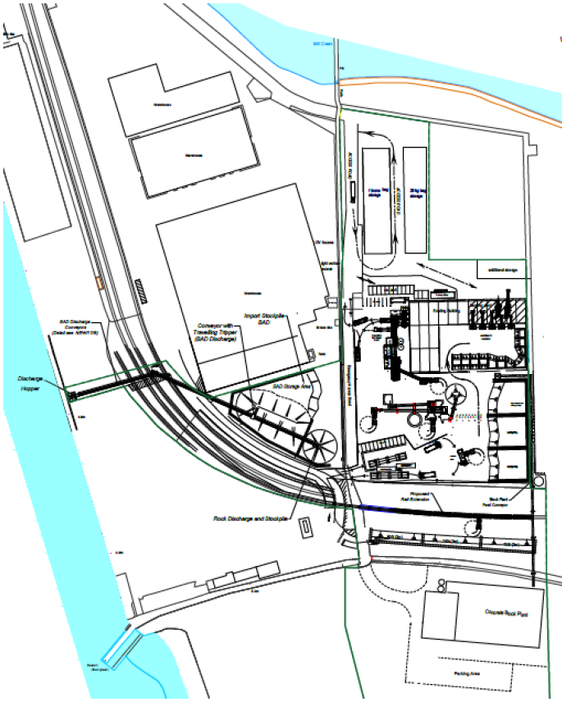

: PROPOSED Site Layout

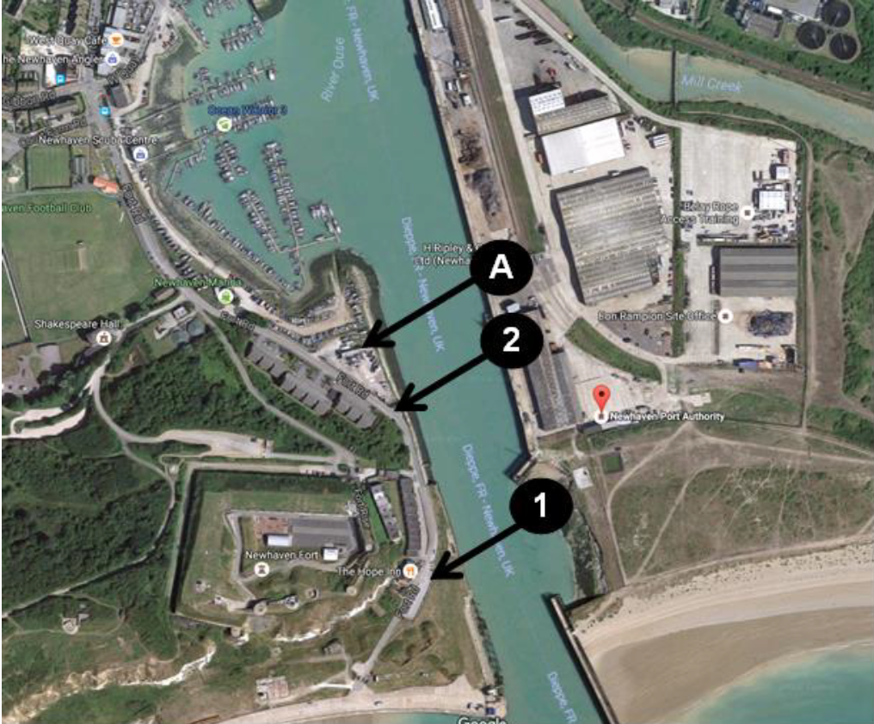

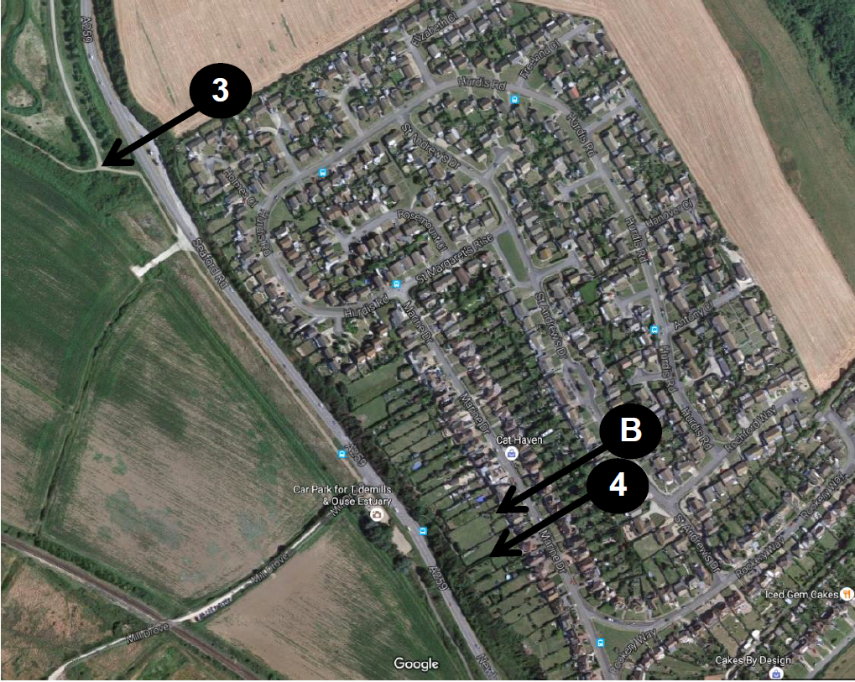

: receptor locations

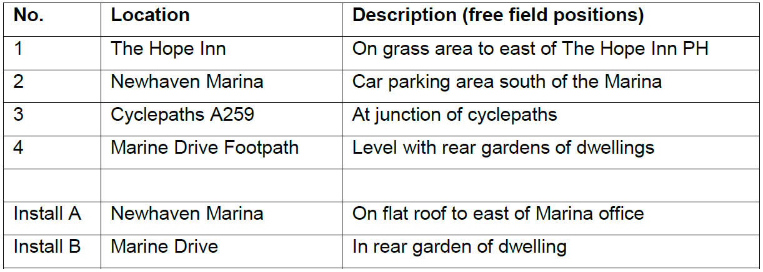

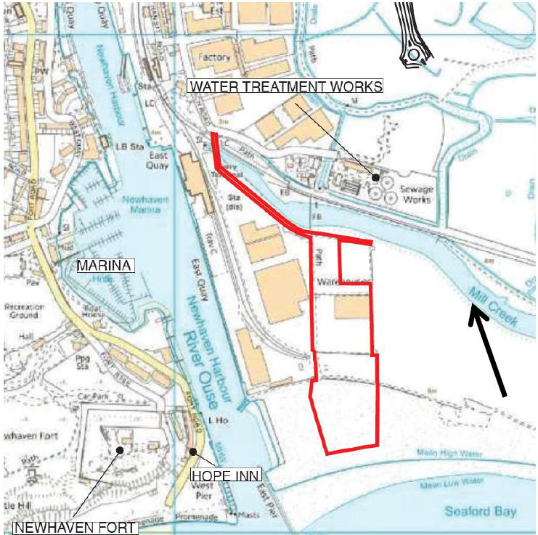

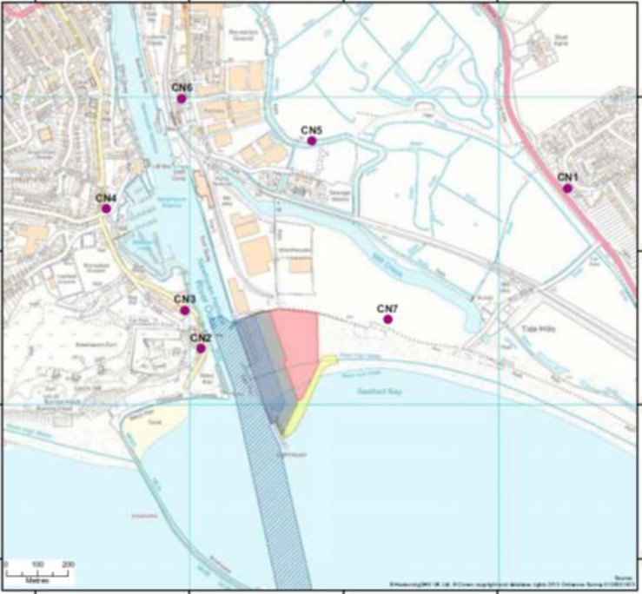

: ECOLOGICAL site AND APPLICATION SITE BOUNDARY

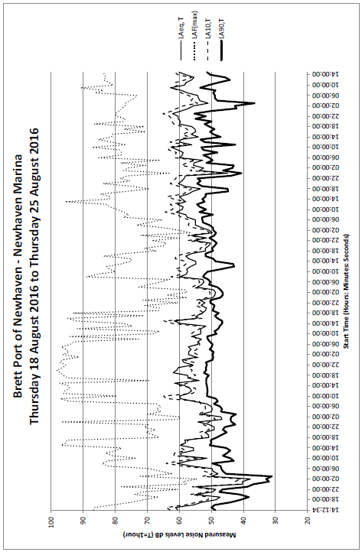

: WBM newhaven marina unattended noise data

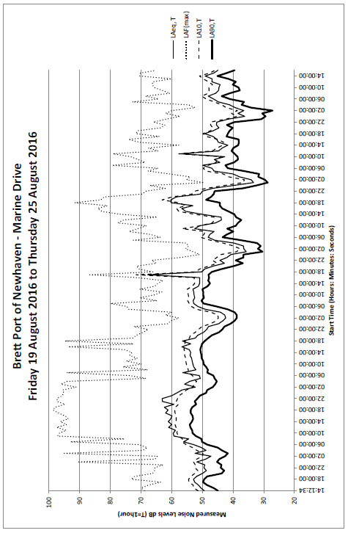

: WBM marine drive unattended noise data

